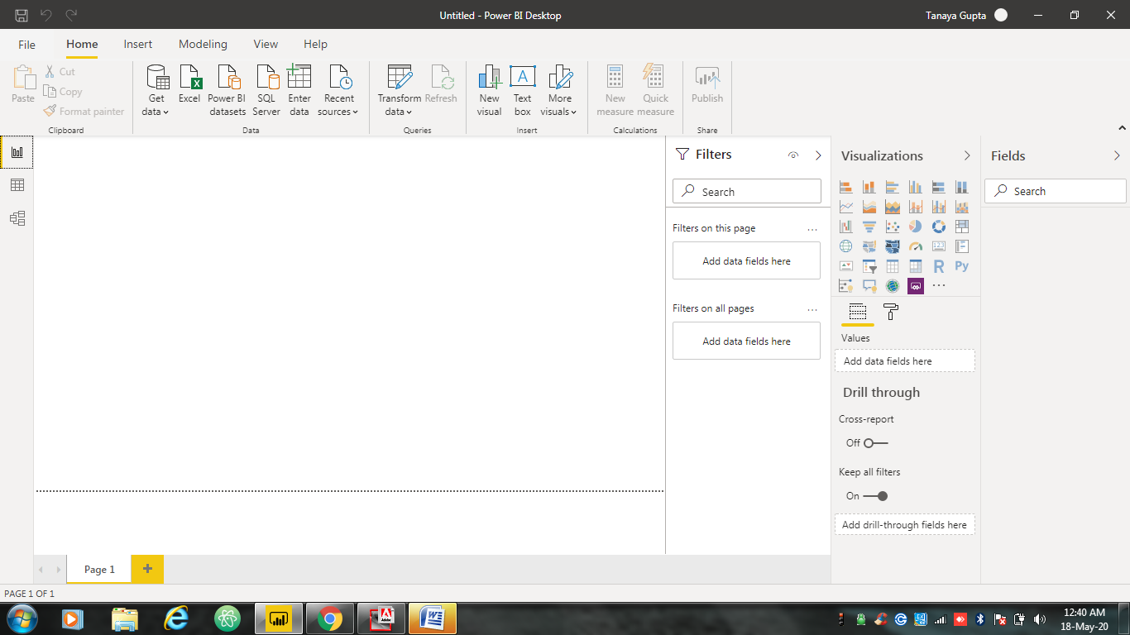

🡨REPORT VIEW

BASICS OF POWER BI

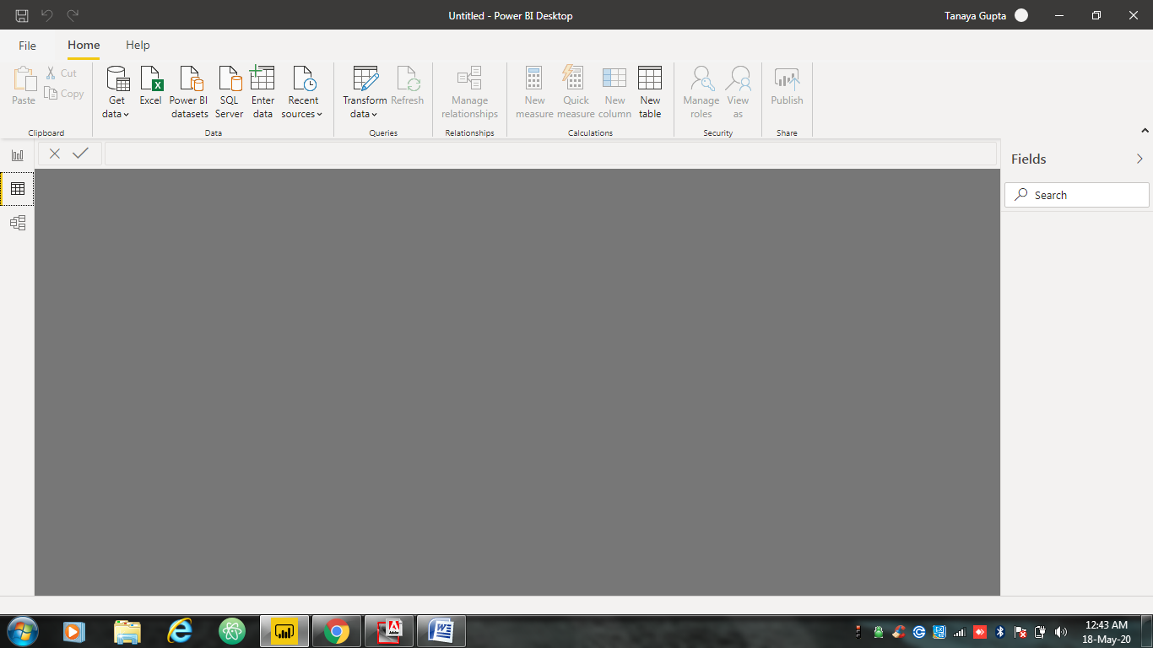

🡨 DATA VIEW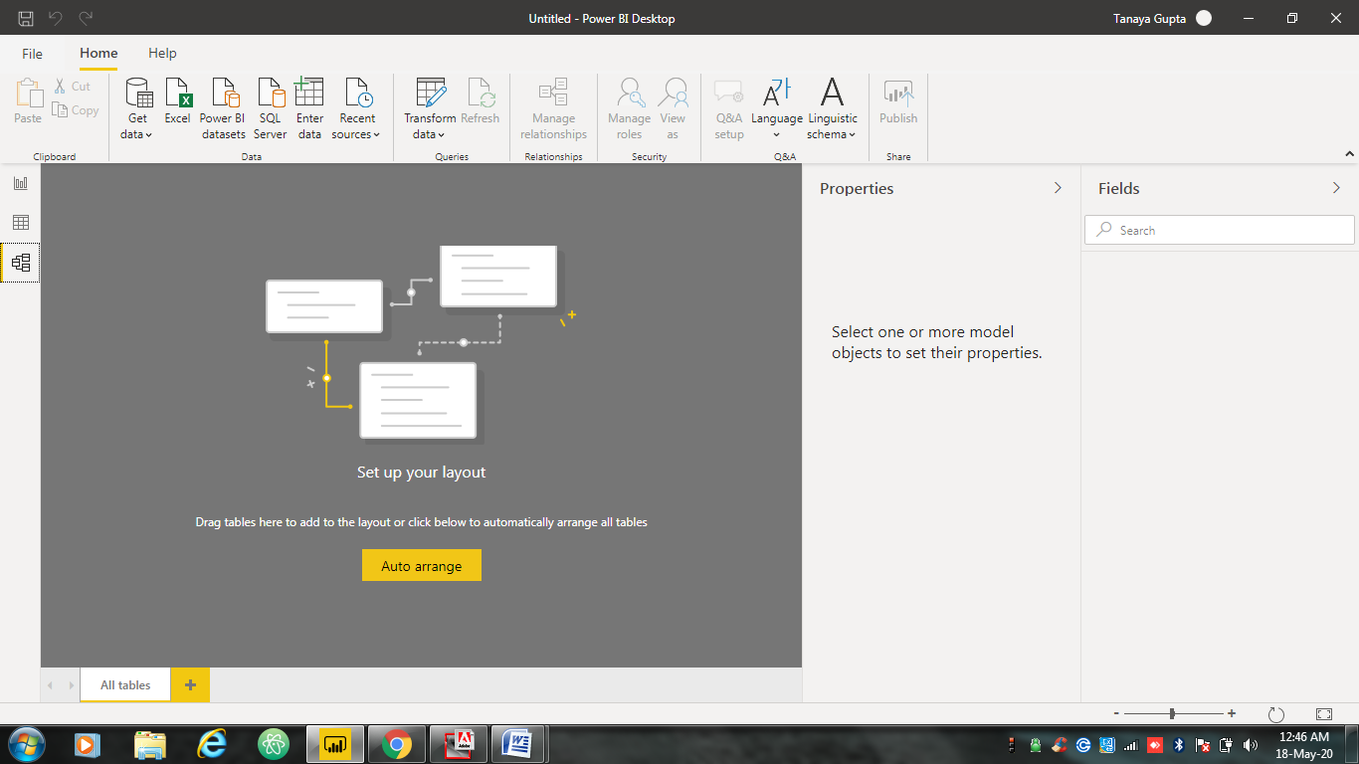



🡨 MODEL VIEW

POWER QUERY EDITOR

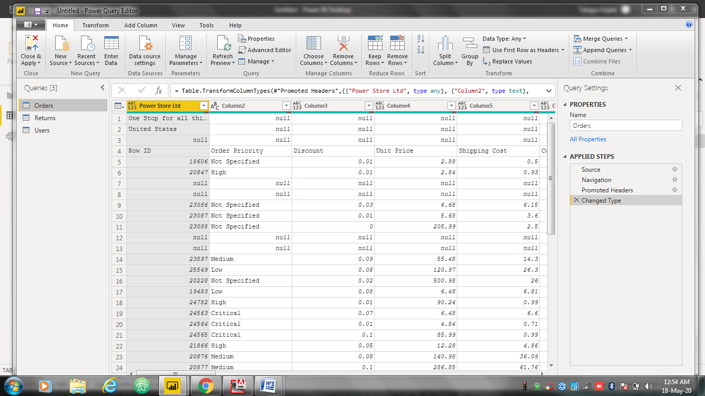

ADVANCE EDITOR

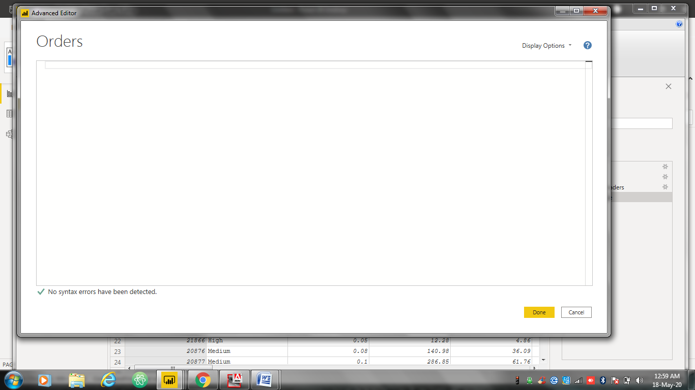

PRICING AND COMPARISONS

Power BI has three pricing plans:

**Power BI Desktop**: Microsoft Power BI is a cloud-based business intelligence and analytics service that provides a full overview of your most critical data. Connecting to all of your data sources, Power BI simplifies data evaluation and sharing with scalable dashboards, interactive reports, embedded visuals and more. This offers free to any single user and includes data cleaning and preparation, custom visualizations and the ability to publish to the Power BI service.

**Power BI Pro**

Characteristics-

* Self-service and modern BI in the cloud
* Collaboration, publishing, sharing, and ad-hoc analysis
* Fully managed by Microsoft
* Maximum size of individual dataset-1 G
* Maximum storage- 10 g per user
* Compute processing environment-Shared

Price**- $9.99** Monthly per user

**Power BI Premium**

Characteristics-

* Enterprise BI, big data analytics, cloud and on-premises reporting
* Advanced administration and deployment controls
* Dedicated cloud compute and storage resources
* Allows any user to consume Power BI content
* Maximum size of individual dataset-10 G
* Compute processing environment-Dedicated

Price **-$4,995** Monthly per dedicated cloud compute and storage resource with annual subscription

### For content creation- Use the free [power bi desktop tool](https://powerbi.microsoft.com/en-us/desktop/) to author reports and prepare, model, and create data visualizations.

### For content publication-Collaborate with colleagues, model data, author content, share dashboards, publish reports, and perform ad-hoc analysis with a power bi pro license.

### For content consumption-Read and interact with pre-published dashboards and reports with either a per-user Power BI Pro license or a Power BI Premium license for large-scale databases.